Report
Of
Internship

Submitted
To
School of Computer Science and Engineering
IILM University, Greater Noida, U.P.

In partial fulfilment of the requirement of degree of
B.Tech CSE



By
Roll Number of Student: 25SCS1003003654
Name of Student: SHEHBAZ MUSTAFA
Batch: 2025-29

2026-27

CANDIDATE’S DECLARATION

I, SHEHBAZ MUSTAFA, do hereby declare that the internship report titled “Web
Development Internship” has been completed by me to fulfil the requirement for the
award of the degree of Bachelor of Technology in CSE. All the references have been
quoted and I have not taken as such any material from any other source. I affirm to
you that this report is my own and has not been submitted to any other institute for
any degree/diploma requirement and further I shall be solely responsible for any kind
of copyright violation in this regard.

Signature:
Student Name: SHEHBAZ MUSTAFA
Roll No.: 25SCS1003003654

ACKNOWLEDGEMENT

I am using this opportunity to express my gratitude to everyone who supported me
throughout the Internship Program. I am thankful for their aspiring guidance,
invaluably constructive criticism and friendly advice during this work. I am sincerely
grateful to them for sharing their truthful and illuminating views on a number of
issues related to this work.

I express my gratitude to my parents for their blessings.

Signature:
Student Name: SHEHBAZ MUSTAFA
Roll No.: 25SCS1003003654

Chapter No. | Chapter Name | Page Nos.
 | Cover Page | ----
1. | Candidate’s Declaration | i
2. | Acknowledgment | ii
3. | Internship Completion Certificate | iii
4. | Project Description  4.1 Introduction  4.2 Organization Profile  4.3 Problem Statement  4.4 Project Objectives  4.5 Scope of the Project  4.6 Technologies and Tools Used  4.7 System Architecture  4.8 Methodology  4.9 Expected Outcomes  4.10 Certificates of  completion &amp; proof | 1  1  2  3  3  4  4  5  6  7  8
5. | Bibliography/References | 9

Chapter 4: Project Description

4.1 Introduction
Front-end web development focuses on constructing user-facing interfaces using core
technologies: HTML5, CSS3, and JavaScript. During the internship as a Web
Developer Intern at Cognifyz IT Solutions, practical exposure was gained in
implementing structured web page layouts, custom responsive styles, client-side event
handlers, and modular scripts.
4.2 Organization Profile
Cognifyz IT Solutions is a technology services firm specializing in software
development, tech consultation, and skill-building internships designed to provide
students with hands-on, industry-aligned software engineering experience.
4.3 Problem Statement
Developing modern web applications requires constructing accessible markup, multi-
device responsive stylesheets, and functional script logic while ensuring clean code
maintainability, fast DOM rendering, and cross-browser consistency.
4.4 Project Objectives
• Build semantic HTML5 structural components.
• Apply CSS3 Flexbox, Grid, and @media queries for multi-viewport responsiveness.
• Write ES6+ JavaScript for DOM manipulation and interactive user interface
controls.
• Host clean source code with structured commits on GitHub.

4.5 Scope of the Project
The scope encompasses front-end application development, responsive CSS styling,
dynamic scripting, performance auditing across browsers, and code version
management on GitHub.
4.6 Technologies and Tools Used
Category Tool / Technology
Markup &amp; Structure HTML5

Styling &amp; Layout CSS3, Flexbox, Grid
Scripting &amp; Logic JavaScript (ES6+)
Version Control Git &amp; GitHub
Development IDE Visual Studio Code

4.7 System Architecture
+-------------------------------------------------------+
| Client Browser |
| |
| +---------------------+ +----------------------+ |
| | HTML DOM Tree | | CSSOM Stylesheet | |
| +----------+----------+ +----------+-----------+ |
| | | |
| +------------+-------------+ |
| | |
| v |
| [Render Tree Engine] |
| | |
| v |
| [JavaScript Event Listeners] |
+-------------------------------------------------------+

4.8 Methodology
1. Requirements Analysis: Analyzing project task specifications.
2. HTML Layout Structuring: Drafting semantic DOM structures.
3. Responsive Styling: Implementing custom responsive styling rules.
4. JavaScript Integration: Writing event listeners and dynamic update logic.
5. Testing &amp; Deployment: Testing across devices and committing to GitHub.
4.9 Expected Outcomes
• Deployment of functional web components and interactive web pages.
• Enhanced knowledge of DOM manipulation, responsive layouts, and modern front-
end scripting.
• Organized GitHub code repository documentation.

4.10 Certificates of completion
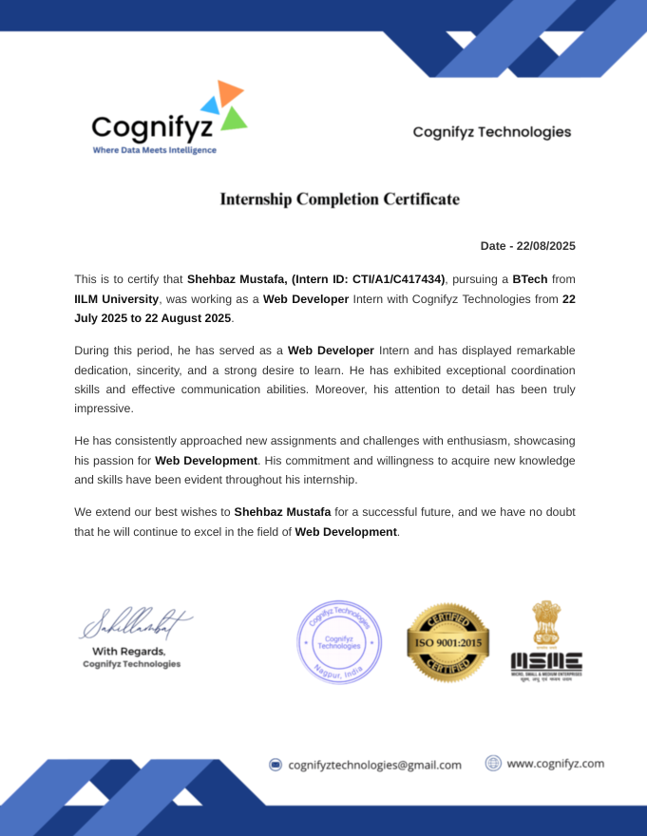

GitHub Repository Link: https://github.com/shehbaz-mustafa/2025-
29_SHEHBAZ_MUSTAFA_25SCS1003003654_3_2CSE5

Chapter 5: Bibliography/References

1. MDN Web Docs. HTML: HyperText Markup Language. Available at:
https://developer.mozilla.org/en-US/docs/Web/HTML
2. MDN Web Docs. CSS: Cascading Style Sheets. Available at:
https://developer.mozilla.org/en-US/docs/Web/CSS
3. MDN Web Docs. JavaScript Documentation. Available at:
https://developer.mozilla.org/en-US/docs/Web/JavaScript
4. W3C. Web Content Accessibility Guidelines (WCAG) 2.1. Available at:
https://www.w3.org/TR/WCAG21/
5. GitHub Documentation. Git Version Control. Available at: https://docs.github.com/

